YOU ARE INVITED TO THE FILM PREMIERE OF
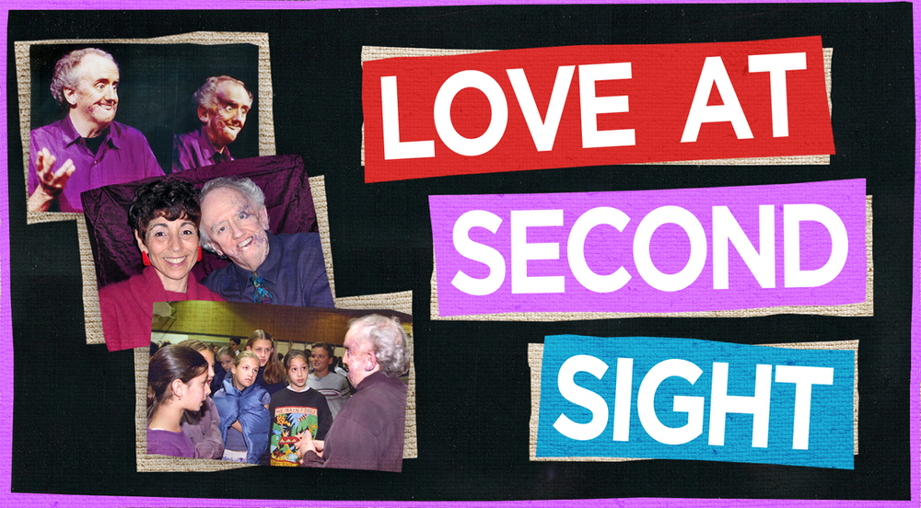

COME AND BE INSPIRED!
MUSIC ~ STORYTELLING ~ POETRY ~ SONG
Special guest, Ann Mortifee

Free admission and guaranteed seating when you RSVP
through the SFU website:
www.sfu.ca/sfuwoodwards/events
(click on Love at Second Sight)

Thursday September 8, 2016
7 p.m. Doors open 6:30 p.m.
At the Djavad Mowafaghian Cinema, in
Simon Fraser University’s Goldcorp Centre for the Arts
149 W. Hastings St., Vancouver
Sponsored by: Simon Fraser University’s Wheelchair accessible
Vancity Office of Community Engagement ASL signing provided
Presenting sponsor: Film is subtitled
Vancouver Adapted Music Society

